

MO-KAN-NE Chapter Feasibility Study Report

Presented to General Assembly November 17, 2025
Prepared by the Feasibility Task Force:
Julie Cayton | Rashawn Harvey | Nicholas Horne | Anna McDonald | Liz Shepard

1. Executive Summary
MKN Committee Restructure Executive Summary
The MO-KAN-NE Chapter of the Educational Opportunity Association (MKN) undertook a comprehensive Feasibility Study to assess volunteer capacity, organizational efficiency, and engagement. Feedback from member surveys and listening sessions revealed the need to streamline MKN’s committee structure to reduce redundancy, clarify leadership pathways, and enhance collaboration across Missouri, Kansas, and Nebraska.
The Feasibility Study reveals that while the MO-KAN-NE Chapter’s volunteer foundation remains strong, the organization’s rapid growth and expanded committee network have stretched its capacity to the limit. The current structure—now encompassing over twenty committees—reflects a thriving, active membership but also highlights inefficiencies in communication, overlapping responsibilities, and unclear role delineation. These factors have created challenges in maintaining engagement and sustaining long-term leadership participation.
Findings from the member survey, listening sessions, and document comparison collectively affirm the need to modernize MKN’s structure for greater efficiency, transparency, and inclusivity. Recommendations center on streamlining committees into functional clusters, strengthening mentorship and onboarding, and considering the introduction of a part-time paid role to manage administrative continuity and coordination. Together, these changes aim to ensure that MKN remains a vibrant, equitable, and sustainable organization that continues to advance educational opportunity across Missouri, Kansas, and Nebraska.

2. Introduction and Background
WHO was a part of the task force:
Co-chairs: Nicholas Horne and Anna McDonald
Members: Julie Cayton | Rashawn Harvey| Liz Shepard
Additional Contributors: Brandon Hammond (Past President) | Erika Sterup (President-Elect)

The approved charge by the Board of Directors was as follows:
“To assess the current roles and responsibilities of board members and committee chairs, review the existing constitution and bylaws for any necessary amendments related to role changes and term limits, identify duties exceeding reasonable volunteer expectations, and develop a potential job description for a paid contracted position.”

3. Timeline of Events
The following section summarizes the chronological development of the Feasibility Study and major milestones that informed its findings.

February 7, 2025 – Board of Directors Discussion
At the February Board of Directors meeting, members held an in-depth discussion on the feasibility of creating a long-term or compensated administrative position within MKN. The conversation focused on sustainability, workload equity, and continuity in key officer roles—especially the Treasurer position.
It was agreed that the first step would be to develop written role descriptions for all board and committee positions to clarify expectations and distinguish duties appropriate for volunteers from those that may require compensation.
Anna McDonald raised the concern that younger professionals are less likely to assume uncompensated duties and encouraged consideration of creative compensation such as conference support or registration coverage.
A motion by Nicholas Horne, seconded by Anna McDonald, established an ad hoc committee to review board duties, consolidate overlapping responsibilities, and submit recommendations to the Board for approval. The motion passed unanimously, formally launching what became the Feasibility Study Task Force.

April 1, 2025 – Consultation with WAEOPP Leadership
Nicholas Horne and Julie Cayton met with leaders from the Wisconsin Association of Educational Opportunity Program Personnel (WAEOPP) to discuss their recent two-year organizational restructuring initiative. The WAEOPP team shared their approach—centered on visioning forums, surveys, and pilot testing of new committee structures—and provided key insights about maintaining member trust during change.
WAEOPP shared resources, including templates and reports, which Nicholas brought back to the full MKN Task Force. These materials later served as a reference point for MKN’s own restructuring process, ensuring alignment with established best practices while preserving chapter-specific flexibility.

April 1, 2025 – Approval of Committee Charge and Work Plan
At the April Board meeting, the Feasibility Study Committee’s charge was formally approved. The committee was tasked to:
“Assess the current roles and responsibilities of board members and committee chairs, review the existing constitution and bylaws for any necessary amendments related to role changes and term limits, identify duties exceeding reasonable volunteer expectations, and develop a potential job description for a paid contracted position.”
The Board adopted a five-phase plan to guide the work:
- Establish committee and define objectives.
- Conduct data collection and analysis.
- Assess roles and draft recommendations.
- Track and amend proposed modifications.
- Explore the potential transition to a contracted position.
A timeline was set spanning March–November, with the goal of presenting findings and recommendations at the EOA Annual Conference during the MKN General Assembly.

April 17, 2025 – Initial Task Force Meeting and Work Planning
The Task Force held its first meeting on April 17, 2025, where members reaffirmed their shared goals: to strengthen transparency, sustainability, and engagement in MKN leadership.
Committee members divided responsibilities:
- Julie Cayton and Nicholas Horne developed questions for the Paul Spraggins Professional Development (PD) listening sessions, designed to gather qualitative feedback from underrepresented regions.
- Anna McDonald and Liz Shepherd began developing a Board and Committee Survey to capture information on workload, responsibilities, and volunteer sustainability.
- The team also agreed to create infographics that visualize leadership pathways and time commitments to improve clarity for potential volunteers.
The meeting reinforced that the process would remain member-driven and data-informed, with WAEOPP resources serving as a guiding reference rather than a prescriptive model.

May 5, 2025 – Confirmation of Listening Session Questions
On May 5, the Task Force met briefly to finalize the four guiding questions for use during the Spraggins PD listening sessions. These questions were designed to explore members’ motivation for involvement, their vision for an engaging organization, their desired emotional experience as professionals, and how leadership could best support engagement.
This step ensured consistency across all listening sessions and alignment with the broader goals of the feasibility study.

May 12, 2025 – Finalization of Leadership Infographics
By May 12, the Task Force completed the MKN Board Position, Committee, and Level Graphic—a comprehensive visual illustrating board positions, associated committees, and required levels of commitment.
The infographic clarified which positions must chair committees, which are ex-officio, and which are open to general membership. It became a key leadership recruitment and onboarding tool, directly addressing member feedback about unclear expectations and leadership pathways.

Summer 2025 – Collaboration with Special Concerns & Affiliations Committee
During the summer, the Task Force identified overlapping efforts with the Special Concerns & Affiliations Committee, which was simultaneously reviewing board duties and responsibilities to develop a Policy and Procedures Manual.
Rather than duplicate work, both groups agreed to collaborate, combining survey and data collection efforts. This partnership ensured consistent data, avoided redundancy, and produced a comprehensive picture of volunteer roles, workload, and organizational needs.

Summer 2025 – Listening Sessions and Data Collection
Throughout the summer, Task Force members led the Paul Spraggins Professional Development listening sessions across St. Louis, Missouri; Southwest Missouri; Lawrence, Kansas; Central Nebraska, and one virtual session.
Each session was recorded through detailed notes and transcripts, capturing members’ voices on engagement, motivation, and leadership experience. Using AI-supported analysis tools, the Task Force synthesized the qualitative data to identify common themes and regional nuances.
This approach produced an unbiased summary reflecting member sentiment, which directly informed the Feasibility Study findings.

August–October 2025 – Pause and Resumption of Work
In August and September, national uncertainty surrounding federal TRIO program funding shifted the organization’s focus toward advocacy and program stability. The Task Force temporarily paused its efforts to allow members to address immediate institutional priorities.
Work resumed in October 2025, when the committee conducted a constitutional review of committees and began drafting the final Feasibility Study Report. Efforts centered on summarizing collected data, aligning recommendations with constitutional provisions, and finalizing the study’s conclusions and next steps for presentation to the MKN Board of Directors.

4. Findings and Analysis
The Feasibility Task Force analyzed survey data, listening session input, and governing documents. Key findings are organized below.

a. Membership Survey Findings
Findings from the MO-KAN-NE Volunteer and Leadership Interest Survey
The MO-KAN-NE Chapter Volunteer and Leadership Interest Survey provided important insights into member engagement, leadership readiness, and perceptions of organizational structure. 73 Responses reveal a committed membership that values professional development and community connection but expresses a need for clearer expectations, more manageable volunteer commitments, and potential structural reform to sustain participation.
1. Membership Demographics and Engagement
Respondents represented a mix of TRIO and EOP professionals, including directors, advisors, and coordinators from programs such as Upward Bound, SSS, and Talent Search. Most respondents reported 1–10 years of membership in the chapter, with a majority confirming they pay dues to EOA.
Approximately a third of respondents currently serve in volunteer or leadership capacities within the chapter, primarily on standing committees or as state representatives.
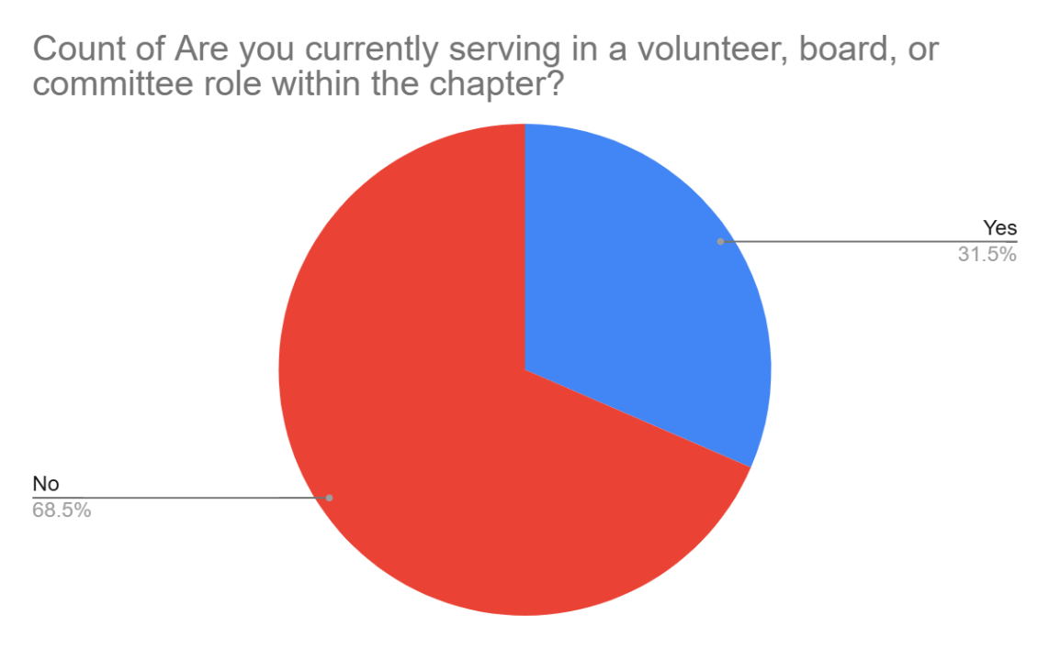
Those not currently serving are most often cited:
- Time constraints and workload
- Unclear expectations or responsibilities
- Uncertainty about the nomination or selection process
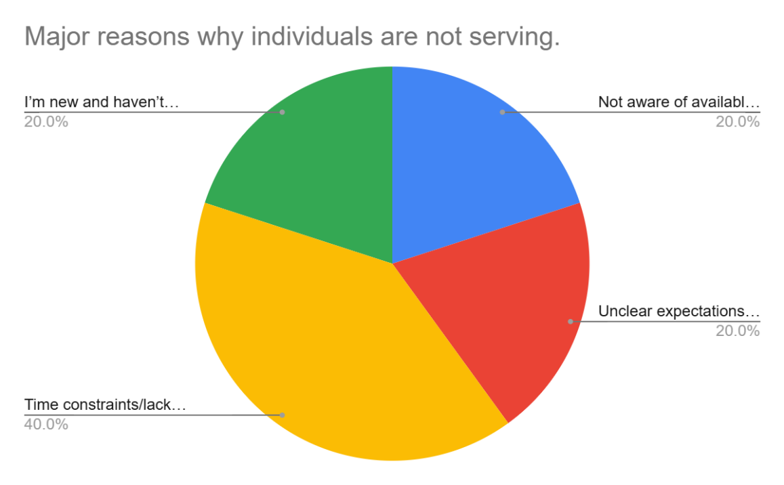
This aligns with the task force’s finding that many members perceive volunteer roles as vague or overly time-consuming for unpaid service.
2. Interest in Leadership Roles and Committees
Several respondents expressed openness to leadership opportunities but emphasized a desire for structured onboarding, mentorship, and role clarity.
Committees generating the most interest for future participation included:
- Professional Development
- New Professionals
- MILE (Members Involved in Leadership & Engagement)
- Student Initiatives and Conferences
A smaller group expressed interest in executive leadership roles (President-Elect, Treasurer, and Member-at-Large), though most qualified this interest with statements such as “if needed, I’ll serve”—indicating willingness but limited proactive pursuit.
One respondent explicitly indicated no current interest due to unclear structure and excessive workload perception, signaling a gap between interest in mission and readiness to serve.
3. Support and Resources Needed for Greater Involvement
Respondents identified several supports that would make them more likely to take on leadership or committee roles:
- Clear documentation of duties and time expectations
- A visible organizational chart or flow of communication
- Mentorship or training for new volunteers
- Recognition of volunteer efforts
One participant specifically suggested “a readily available and clear construction of leadership and committee duties”—a direct call for the standardization of role descriptions and onboarding processes.
4. Understanding of Current Leadership Roles
When asked which Board positions were unclear in their responsibilities, multiple respondents cited Member-at-Large, Parliamentarian, and State Representative roles as confusing or insufficiently defined.
5. Views on Term Limits
Nearly all respondents indicated they were open to changes in term limits for Board and committee positions. Comments reflected a belief that longer terms allow leaders to complete their vision and provide continuity in planning and implementation. There was no indication of resistance to exploring structural changes in leadership terms.
6. Potential Creation of a Contracted Administrative Position
Every respondent addressed the question regarding the possible creation of a contracted administrative or operational support position. Responses ranged from neutral curiosity to strong endorsement:
Several members rated 5 (strongly agree), citing the organization’s growing size and complexity: “We have gotten too large for there to be no paid position.”
Others rated moderate agreement (3–4), expressing the need for “more information on cost, duties, and oversight.”
A small minority were unsure, citing limited knowledge of current operations.
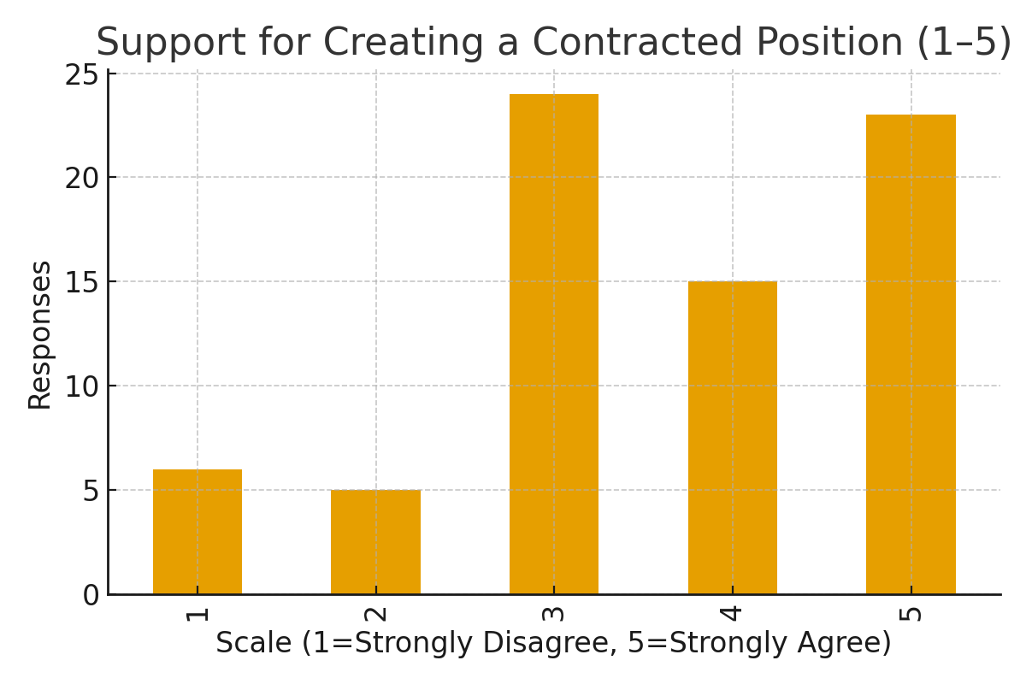
Synthesis Summary for Feasibility Report
Overall, the Excel survey data underscores a membership that is highly supportive of the chapter’s mission but strained by unclear expectations and limited capacity. The responses validate the Task Force’s charge to:
- Clarify leadership and committee structures, including time expectations and term lengths.
- Develop onboarding and mentorship processes for volunteers.
- Evaluate the sustainability of the current volunteer model, considering whether key administrative and operational functions necessitate a paid contracted position.
- Enhance transparency and documentation through written job descriptions and visual organizational tools.

b. Member Listening Sessions (Spraggins PD Grant)
As part of the Feasibility Study process, the Task Force utilized the Paul Spraggins Professional Development Grant to host a series of targeted listening sessions across the MO-KAN-NE region. These sessions were intentionally designed to engage professionals from historically underrepresented or less active areas within the Chapter—St. Louis, Missouri; Southwest Missouri; Lawrence, Kansas; Central Nebraska; and one virtual chapterwide session. The intent was to create meaningful opportunities for dialogue and to collect qualitative data reflecting member experiences, motivations, and needs related to engagement within the Chapter.
Each listening session was facilitated as an open conversation guided by four primary questions:
- What was or would be your motivation to get involved in your EOA Chapter (MKN)?
- What would an engaging and active organization look like to you?
- How have you felt, or how would you like to feel when you’re involved in a professional organization?
- How can the Chapter leadership assist you in reaching your desired level of involvement or engagement in your EOA Chapter (MKN)?
These questions were chosen to capture both the practical and emotional dimensions of member engagement. Participants were encouraged to speak candidly about their experiences, challenges, and aspirations. The following section synthesizes the major themes and takeaways that emerged from these discussions, integrating insights across all listening sites.
Motivations for Involvement
Participants across all regions expressed a shared desire for connection, growth, and contribution. Many noted that their initial involvement came through personal invitation or encouragement from a colleague or supervisor, highlighting the importance of direct outreach and mentorship in engagement. Members from newer or rural programs, such as those in Southwest Missouri and Central Nebraska, particularly valued the Chapter as a means to combat professional isolation and build relationships with others who understand TRIO’s unique context.
Involvement was often described as both personally and professionally rewarding—a balance between giving back to the TRIO community and gaining valuable leadership experience. Several members emphasized that serving in committees or leadership roles helped them develop skills transferable to their institutions, such as budgeting, event planning, or parliamentary procedures. Others mentioned that they appreciated opportunities to apply their strengths in ways not always available in their daily work, such as mentoring new professionals or contributing to advocacy efforts.
Notably, participants appreciated small, well-defined opportunities that allowed them to “get their feet wet” without feeling overwhelmed. Many stressed that clear expectations and limited time commitments encouraged them to take on new responsibilities, while ambiguity or overextension discouraged sustained participation.
What an Engaging and Active Organization Looks Like
Members described an engaging organization as one that is connected, accessible, and responsive. Across all sessions, participants voiced a desire for more intentional communication channels that make it easy to stay informed without feeling overwhelmed. The prevalence of emails from multiple sources (COE, EOA, and MKN) was described as “too much noise,” leading to important information being overlooked. Suggestions included:
- Creating targeted communication lists by professional role (e.g., directors, academic coordinators, tutors).
- Utilizing a shared communication platform such as the Band app or a forum for peer exchange.
- Publishing a concise weekly or monthly newsletter highlighting key updates and opportunities.
Participants also envisioned regional professional development and networking events that are affordable and locally hosted, allowing smaller programs to engage more frequently without significant travel costs. These “drive-in” or half-day gatherings were cited as practical ways to build community, especially for professionals in the St. Louis and rural Nebraska areas.
Members consistently emphasized clarity and transparency around opportunities for involvement. They expressed that not knowing what each committee does—or how much time is required—creates hesitation. Visual tools, such as an infographic outlining levels of engagement (e.g., light, moderate, and intensive time commitments), were suggested as a way to make volunteerism feel more manageable and attainable.
How Members Want to Feel in a Professional Organization
Beyond logistics, participants spoke passionately about how they want to feel when part of MKN. The words most frequently associated with positive engagement were valued, included, and supported. Members said they want to experience a sense of community and belonging, where their contributions are noticed and appreciated.
Several attendees raised the importance of representation and inclusivity, both in leadership and in how the Chapter engages its membership. Members want to see themselves reflected in committees and decision-making bodies, particularly professionals from smaller programs, veterans’ initiatives, and rural institutions.
Another strong theme was the recognition that engagement styles differ. Introverted members expressed that typical networking or conference environments often favor extroverts, and they valued opportunities for quiet participation, such as asynchronous collaboration or written feedback tools. The term “psychological safety” surfaced multiple times, referring to environments where members can contribute without fear of judgment or pressure to speak publicly.
Participants also said they value an organization that is positive, approachable, and fun—a space where they can relax, laugh, and build genuine relationships. Recognition, even in simple forms like thank-you notes or public acknowledgment, was cited as a meaningful motivator that reinforces members’ sense of purpose.
How Leadership Can Support Engagement
Across sessions, participants were clear that leadership has a crucial role in creating pathways for sustainable involvement. They called for greater transparency, structure, and follow-through. Members want to know:
- Who to contact to get involved in a committee.
- What the actual time commitment is (hours per month, term length, and meeting frequency).
- How many people currently serve in each area and whether there are open positions.
Participants also recommended that committee chairs personally reach out to interested individuals and provide short, clear descriptions of their group’s goals and responsibilities. When members expressed interest but received no follow-up, engagement stalled.
Several participants suggested the Board conduct a review and consolidation of committees, noting that the current structure—with over twenty listed committees—appears daunting and potentially duplicative. They proposed combining overlapping groups to make leadership more efficient and approachable.
Finally, participants stressed that leadership should model accessibility and relational connection—knowing members by name, checking in, and celebrating accomplishments publicly. As one participant summarized, “It’s not that people don’t want to get involved—they just want to know where they fit and that it matters when they do.”
Key Takeaways for the Feasibility Study
The listening sessions confirmed that member engagement within MKN is driven as much by human connection as by organizational design. To strengthen participation, future structural or staffing recommendations should prioritize:
- Simplifying communication and creating consistent, user-friendly platforms.
- Clarifying volunteer expectations through written role descriptions and visual commitment guides.
- Enhancing inclusivity by recognizing different engagement styles and expanding representation across geography and program type.
- Streamlining committees to align efforts and reduce duplication.
- Building a culture of recognition and relational leadership that encourages personal outreach and appreciation.
In essence, members across all five listening sites expressed deep commitment to the Chapter’s mission. Their feedback reinforces that MKN’s strength lies not just in its programs, but in the relationships and belonging it fosters—elements that must remain central as the organization evaluates its structure, roles, and potential pathways toward professional sustainability.

C. Committee Comparison Findings
As part of the organizational review conducted through the MO-KAN-NE Feasibility Study, a comparative analysis was performed between the MKN Constitution and Bylaws (2021) and the 2024–2025 Committee Charges document. This comparison aimed to identify areas of structural expansion, evolution of duties, and the emergence of new committees that reflect the chapter’s current operational realities and strategic priorities.
The Constitution (amended in 2021) outlines twelve standing committees, each focused on core operational and governance functions. By contrast, the 2024–2025 Committee Charges document demonstrates significant organizational growth, listing over twenty-two committees, including new subcommittees and ad hoc working groups designed to address specialized tasks and enhance member engagement.

MKN Committees Comparison: Constitution vs. 2024–2025 Charges
Committee Name | In the Constitution (2021) | 2024–2025 Committees | Status / Notes
Membership & Certification | ✅ Yes – Standing Committee (Art. 9.3.1) | ✅ Yes | Unchanged; duties expanded (added collaboration with Alumni and New Professionals).
Research & Evaluation | ✅ Yes – Standing Committee (Art. 9.3.2) | ✅ Yes | Expanded scope — includes design of evaluation tools and data analysis support.
Special Concerns & Affiliations | ✅ Yes – Standing Committee (Art. 9.3.3) | ✅ Yes | Expanded role — now includes MILE program redevelopment and crisis response (e.g., pandemics, disasters).
Legislation & Education | ✅ Yes – Standing Committee (Art. 9.3.4) | ✅ Yes | Expanded; includes advocacy and alumni coordination for TRIO Day and Policy Seminar.
Fair Share | ❌ No (only referenced in officer duties, not as a committee) | ✅ Yes | Separate standing group focused on COE contributions and fundraising drives.
Scholarships | ✅ Yes – Standing Committee (Art. 9.3.5) | ✅ Yes | Expanded; now collaborates with Scholarship Fundraising and EOA scholarship processes.
Public Relations & Communications | ✅ Yes – Standing Committee (Art. 9.3.6) | ✅ Yes | Expanded; now manages social media, branding, and Band app creation.
Professional Development | ✅ Yes – Standing Committee (Art. 9.3.7) | ✅ Yes | Broadened to include hybrid/virtual PD and state-specific events; coordinates with multiple committees.
Annual Conference | ⚙️ Subcommittee (under Professional Development) | ✅ Yes – Independent listing | Functionally same but formalized as its own committee in practice.
New Professionals | ⚙️ Subcommittee (under Professional Development) | ✅ Yes – Independent listing | Now treated as a standalone operational committee.
MILE (Members Involved in Leadership & Engagement) | ⚙️ Subcommittee (under Professional Development) | ✅ Yes (not active this year) | Currently on hiatus and being restructured; previously under PD.
Student Initiatives & Conferences | ✅ Yes – Standing Committee (Art. 9.3.8) | ✅ Yes | Maintained; expanded duties include revenue goals and cross-committee coordination.
Heartland Research Conference | ❌ No | ✅ Yes | New Committee. Focuses on McNair Heartland Research Conference planning.
Finance | ✅ Yes – Standing Committee (Art. 9.3.9) | ✅ Yes | Expanded; now includes fiscal audits, investment planning, and e-payment system reviews.
Nominations & Elections | ✅ Yes – Standing Committee (Art. 9.3.10) | ✅ Yes | Expanded; integrates “Nominations & Elections Taskforce” to increase candidate engagement.
Technology | ✅ Yes – Standing Committee (Art. 9.3.11) | ✅ Yes | Unchanged; new tasks include “Ask MKN” feature and expanded online support.
Advocacy & Recognition | ✅ Yes – Standing Committee (Art. 9.3.12) | ✅ Yes | Expanded umbrella now includes four formalized subcommittees.
TRIO Day & First-Generation Celebrations | ❌ No | ✅ Yes | New Subcommittee. Promotes and documents state and regional TRIO/First-Gen events.
Alumni Engagement | ❌ No | ✅ Yes | New Subcommittee. Builds alumni networks, manages alumni directory, and links with advocacy efforts.
MKN Achievers | ⚙️ Mentioned within Advocacy & Recognition | ✅ Yes – Separate Listing | Formalized Subcommittee. Manages Achiever nominations and recognition.
MKN Hall of Fame | ⚙️ Mentioned within Advocacy & Recognition | ✅ Yes – Separate Listing | Formalized Subcommittee. Oversees Hall of Fame selection and ceremony.
Scholarship Fundraising | ❌ No | ✅ Yes | New Ad Hoc Committee. Handles raffle, auction, and scholarship funding efforts.
Future Conference Site | ❌ No | ✅ Yes | New Ad Hoc Committee. Secures future hotel/conference venue bids.
Enhanced Educational Opportunity Fund (EEOF) | ❌ No | ✅ Yes | New Ad Hoc Committee. Manages award disbursement and selection for special student opportunities.

This expansion reflects a deliberate shift from a foundational governance model to a functionally diversified structure, emphasizing advocacy, recognition, event planning, and fundraising. The growth in committee structure indicates a more distributed approach to leadership, allowing for targeted work aligned with evolving member interests and the chapter’s strategic direction.
Structural and Functional Evolution
Several committees that were previously treated as subcommittees—such as Annual Conference and New Professionals—have become fully independent, underscoring their significance to chapter operations. This move allows for clearer delegation of responsibilities, improved event management, and more consistent member participation opportunities.
The Advocacy & Recognition and Professional Development committees serve as umbrella entities for multiple specialized teams, reflecting a more integrated and modular structure. This aligns with national best practices in nonprofit governance and mirrors restructuring models adopted by regional counterparts such as WAEOPP, which have grouped committees into strategic focus areas (Professional Opportunities, Membership, Finance, and Communications).
Summary
In sum, the comparison underscores a chapter in transition—evolving from a traditional volunteer-led governance model into a modern, functionally integrated organization. The additional committees introduced since 2021 reflect responsiveness to member needs, stronger community engagement, and alignment with EOA strategic priorities.
As MKN continues its restructuring efforts, the next phase of feasibility work should focus on refining this structure for sustainability, possibly through consolidation into larger “committee clusters” or “functional teams” modeled after the WAEOPP approach. This evolution will help balance inclusivity with efficiency while maintaining the chapter’s strong emphasis on professional development, advocacy, and recognition.

d. Volunteer Capacity and Workload Analysis.

As part of the Feasibility Study, the Task Force conducted a detailed workload and responsibility review of all standing and ad hoc committees using committee chair interviews, document review, and self-reported time commitments. The committee meeting question documents were gathered and synthesized through the coordinated efforts of the Past-President, working in conjunction with the Special Concerns and Affiliations Committee as part of that committee’s broader policy and procedures review charge. This collaboration ensured consistency in how committee feedback was collected and analyzed across all standing and ad hoc groups. This analysis was compiled into a “Volunteer Overload Index” (Figure 1), visually mapping each major leadership role’s relative time intensity and task complexity.

The findings reveal that several positions currently exceed the sustainable threshold for a volunteer-run organization:

Treasurer – Requires ongoing administrative and compliance oversight, averaging 8–10 hours weekly. Duties include managing accounts, reconciliations, credit card processes, tax filings, and contracts, often without administrative support.

Technology Committee – Year-round operational support role responsible for all digital infrastructure, registration systems, and social media platforms, with peak activity during conferences.

President-Elect / Professional Development / Annual Conference – Strategic leadership roles that combine planning, training, and event coordination responsibilities, leading to sustained overextension.

Public Relations & Communications – High creative and technical workload; responsible for branding, social media, and dissemination of information in collaboration with Technology.

State Representatives – Serve across multiple committees (Fair Share, Legislation & Education, New Professionals, Membership), requiring continual outreach across three states.

Research & Evaluation – Data collection, survey design, and reporting responsibilities typically managed by a single volunteer, with high analytical demands.

Secretary – Administrative duties linked to all board and general assembly meetings, requiring timely minutes and coordination across multiple committees.

These roles collectively demonstrate the organization’s growing reliance on professional-level administrative labor. The Volunteer Overload Index (see Figure 1) highlights that operational and technical roles—particularly Treasurer and Technology—carry the highest combined strain, suggesting that key functions have evolved beyond what is reasonable for a volunteer model.
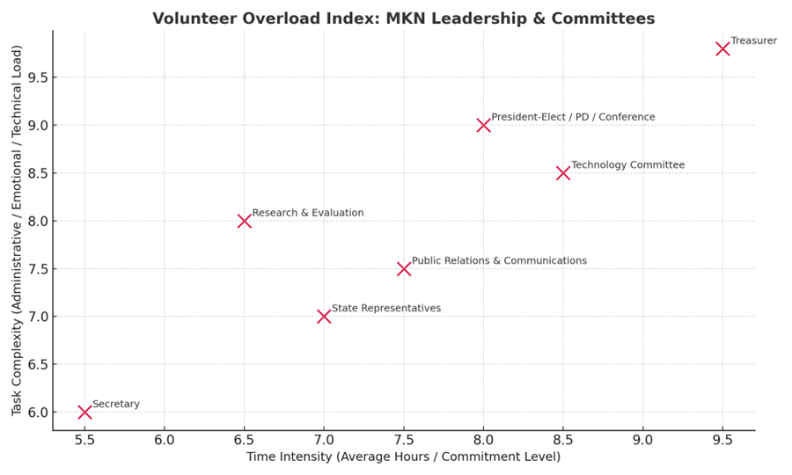Figure 1. Volunteer Overload Index visualizing time intensity and task complexity across MKN leadership roles.
While the majority of board and committee roles were represented, it is important to note that no committee meeting question documents were received for the President, Kansas State Representative, Parliamentarian, or Members-at-Large. As such, the workload analysis and Volunteer Overload Index reflect all available data but may underrepresent leadership perspectives or administrative burdens specific to those positions.
Future assessments should intentionally include all elected and appointed positions to ensure a fully comprehensive evaluation of leadership capacity across the Chapter.
This analysis reinforces the feasibility study’s central conclusion: MKN’s growth and diversification have outpaced the capacity of an all-volunteer structure. Sustaining long-term efficiency and equity will require targeted streamlining, clearer role delineation, and exploration of compensated administrative support.

5. Options or Alternatives
Option 1: Maintain current structure with clarified committee roles and stronger communication protocols.
Option 2: Streamline committees into larger functional areas (e.g., Professional Development, Membership, Operations).
Option 3*: Introduce a part-time paid contracted position to assume key administrative/operational responsibilities. *NOT RECOMMENDED AT THIS TIME*
Option | Advantages (Pros) | Challenges (Cons) | Resource Implications
Option 1: Maintain current structure with clarified committee roles | Retains familiarity and requires minimal immediate change; low financial cost. | Does not address underlying volunteer fatigue; improvements depend on consistent follow-through. | Minimal budget impact; moderate time commitment for policy/role documentation updates.
Option 2: Streamline committees into larger functional clusters (e.g., Professional Development, Membership, Operations) | Improves efficiency, reduces redundancy, and strengthens cross-committee collaboration; aligns with WAEOPP and EOA best practices. | Requires constitutional amendments and cultural adjustment; potential loss of autonomy for some committees. | Staff/volunteer time needed for transition planning; modest budget for communications, training, and documentation.
Option 3*: Introduce a part-time paid contracted position (0.25–0.5 FTE) | Provides continuity, reduces volunteer workload, ensures consistent communication and recordkeeping; enhances professionalism. | Requires sustainable funding source; governance policies must define supervision and accountability. | Estimated annual cost: $10,000 -$15,000, depending on hours and contract terms; budget reallocation or grant support likely required.

6. Conclusions
MKN’s structure has expanded in response to member needs, but the proliferation of 20+ committees, overlapping duties, and unclear expectations creates barriers to sustainable volunteer leadership. Member feedback supports streamlining and clarifying roles and exploring targeted paid support.
The proposed structural refinements are not merely operational but mission-driven. By reducing barriers to volunteer participation and improving communication flow, MKN strengthens its ability to advance equity and access—ensuring that professionals from all program types, institutional sizes, and geographic areas have equal opportunities to contribute and lead. Streamlining committees and establishing clear pathways for engagement directly support inclusion, transparency, and member empowerment.
From a sustainability perspective, these recommendations foster long-term organizational health by distributing leadership more equitably, formalizing processes that have historically relied on institutional goodwill, and creating a framework that can adapt to membership growth. Implementing a small-scale paid support role represents a strategic investment in the Chapter’s future—preserving MKN’s collaborative volunteer spirit while enhancing its capacity to deliver consistent, mission-aligned impact across Missouri, Kansas, and Nebraska.

7. Recommendations
Short-Term (0–12 months):
• Publish clear role descriptions and time expectations for all committees and elected roles.
• Combine overlapping committees into draft clusters for pilot (e.g., Advocacy & Recognition family; PD family).
• Stand up a monthly newsletter or digest; create role-based listservs (directors, coordinators, etc.).
Mid-Term (12–18 months):
• Pilot the streamlined clusters; evaluate workload, participation, and outcomes.
• Draft specific constitutional/bylaw amendments needed to sustain the structure.
Long-Term (1–3 years):
• Conclude the pilot of the streamlined cluster, review, and analyze findings and results of restructuring. Adapt as needed
• Re-evaluate a part-time contracted role to manage administrative continuity, communications cadence, and event coordination.
• Build a funding plan (budget reallocation, sponsorship, grants) for the role if identified as needed

8. Implementation Plan
Phase 1 (Board Action): Approve recommendations; launch communications to members; form restructuring workgroup.
Phase 2 (Pilot –2 years): Implement committee clusters; track volunteer hours, meeting cadence, and deliverables.
Phase 3 (Evaluate & Amend): Report outcomes; finalize constitutional/bylaw language; prepare membership vote.
Phase 4 (Scale & Staff): Adopt revisions; recruit and onboard contracted support if needed; establish annual review cycle.

