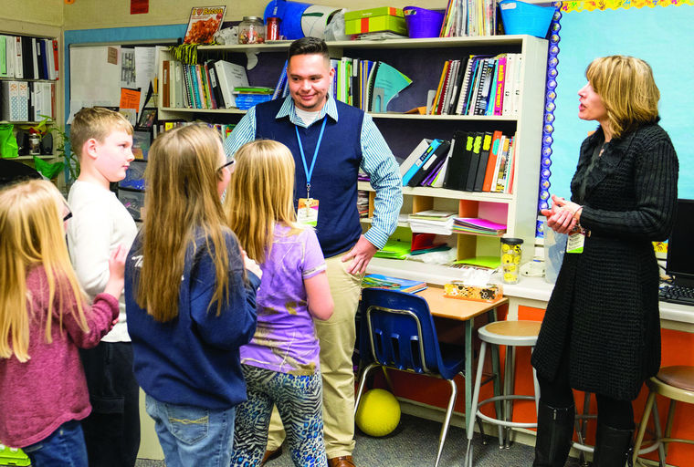
Emporia State University TRIO Alum Wins Outstanding Award for Teaching
The mission of the Kansas Horizon Award Program, administered through the Kansas State Department of Education, is “to recognize exemplary first-year teachers who perform in a way that distinguishes them as outstanding.”
Manuel Estrada Espinoza, a third grade teacher at Walnut Elementary School in Emporia, Kansas, was recently recognized as one of 32 Horizon Award winners in Kansas. Manuel was an active participant in the Emporia State University (ESU) Talent Search program while a student at Emporia High School and the ESU Student Support Services program. His dedication to obtaining a postsecondary degree (a first-in-the-family accomplishment) was always evident and he demonstrated an outstanding work ethic in making this goal a reality.
Manuel is in his second year of teaching and was nominated by his principal, Allison Harder, and the district superintendent, Theresa Davidson. “Mr. Estrada is an exemplary teacher not only through the instruction and structure that he provides for his students in his classroom but the understanding he exhibits by constantly role modeling expectations,” said Principal Allison Harder.
Manuel was born in Mexico and moved to the United States; as an ESL student, he experienced the struggles of learning a new language. He was told by a teacher that he did not have a future in teaching because of his background and limited English skills. “Over the years, I was able to turn that experience into one of my main sources of motivation. Thanks to that memory, I now know what I do not want my students to feel and how I want them to see me, he said. “Regardless of their social or economic status, heritage, and background story, it is crucial to make a connection with them and do not give up on them. Always believe in your students.”
Manuel will be presented with his award at the Kansas Exemplary Educators Network Conference on February 20th in Topeka, Kansas.
Excerpts from the Emporia Gazette Newspaper

